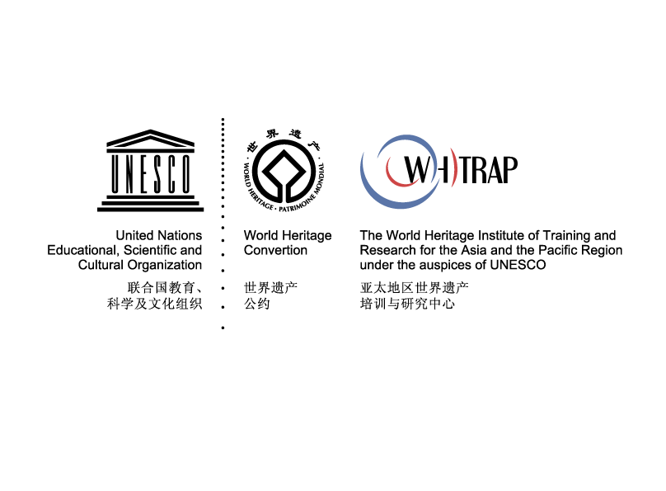
Entry Form

World Heritage Institute of Training and Research for the Asia and the Pacific Region under the auspices of UNESCO | WHITRAP

The 44th Session of World Heritage Committee
The Side Event on “World Heritage Education for the Future”

Global Call for Innovative Case Studies
on World Heritage Education

Entry Form 2021

Side Event on “World Heritage Education for the Future”
at the 44th Session of World Heritage Committee

Global Innovative Case Studies on World Heritage Education
Entry Form

Please make sure you read the following instructions carefully before filling in the form.

- The standard application form is prepared by the World Heritage Institute of Training and Research for the Asia and the Pacific Region under the auspices of UNESCO (WHITRAP) and shall not be altered in any way. Kindly note, only this standard form will be accepted and considered as eligible.

- The form must be submitted in English by 14 June 2021 at 23:50 (UTC+8).

- Please note that word limits are enforced and that it will not be possible to enter additional text once the limit is reached. Use the “Word Count” function to ensure that your do not exceed these limits.

- All sections of the Form shall be duly completed. The information provided should not be repeated across different sections unless it is relevant to these sections. In case of lack of information for any of the section(s) or field(s) concerned, the applicant is requested to enter the following phrase “No relevant information to provide”.

- Basic Information
  - Title of Case：
  - Applicant (Institution/Individual)：
  - Contacts
    - Stakeholder/entity leading the case
（Note: the person in charge will attend the side event and present the case if the case is selected.）
1.3.1.1Name：
1.3.1.2Position and Title：
1.3.1.3Email：
1.3.1.4Telephone number：
    - Communication Contact
（Note: The communication contact will be responsible for supporting the communication efforts during application process. Leave this section blank if the contact are the same as 1.3.1.）
1.3.2.1Name：
1.3.2.2Position and Title：
1.3.2.3Email：
1.3.2.4Telephone number：

- Case-Study Description
  - Brief synopsis of the proposed case-study (Max.750 words)
The summary should cover basic program description, major participants and partners and targeting groups.

  - Objectives and Results (Max.500 words)

  - Explanation of how the case-study conforms with the selection criteria (Max.500 words for each criterion)
Explanation must be made to justify how the proposed case study meets the 2.3.5 “Exemplary Significance” and at least one more criterion among the other four.
2.3.1 Innovation: innovation and explorations made in the concept and approach to heritage education

2.3.2 Technological Application: utilizing creative or advanced technology to protect and promote heritage values

2.3.3 Collaboration: high-level multilateral cooperation mechanism and innovative model to promote heritage education

2.3.4 Sustainability: socially, economically and culturally sustainable and contributing to the sustainable development of heritage site

2.3.5 Exemplary Significance: establishing a good role model in terms of the overall or specific approach worthy to be promoted internationally

- Other materials and requirements
  - Image file (mandatory)
- The applicant must provide minimum 3 photographs to be included in application dossier as annex to email. All photographs must be clearly labeled, preferably in JPG format with a minimum size of 1mb.The photographs must be provided with the consent of the authors/original owners.
  - Video file (optional)
- The applicant may provide a 5-to-15-minute-long clip as annex to email (optional). the video must be clearly labeled and in AVI format with English subtitles. The videos must be provided with the consent of the authors/original owners.
  - Media coverage documentation (optional)
- Photos, texts, links or tables of media coverage sent as annex to email
  - Cession of Rights and Declaration Form (mandatory)
- See the following page. Please print, sign and scan to send back this document with the entry form.

CESSION OF RIGHTS AND DECLARATION FORM
      - CESSION OF RIGHTS
I, the undersigned, ,as a legitimate authorized representative of (enterprise/institute/organization), hereby grant to WHITRAP the non-exclusive right to use, publish, reproduce, distribute, display, communicate or make available to the public, in any language or form and by and means including digital, the following material(s), in whole or in part. I grant these rights to WHITRAP irrevocably, for an unlimited period of the time and for the entire world.

      - DECLARATION FORM:
I, the undersigned, ,as a legitimate authorized representative of (enterprise/institute/organization), hereby
1). declare that all the information provided in the entry materials is accurate.
2). Confirm that all entry materials provided is in no way involved in any legal disputes; and
3). confirm that all entry materials are in no way whatever a violation or an infringement of any existing copyright or license, or is/are my own property or have provided with the full consent of the authors/original owners.

Signature of submitter:
Date:
Official stamp：

